LAB PROGRAMS
Day 4- 19/01/2026
Name: R Prashanth Naik
Register Number: 192472272
Course: CSA0412-Fundamentals of Data Science for Data Analytics

Experiment 16
import pandas as pd
import re
from collections import Counter
df = pd.read_excel("customer_reviews.csv")
print("Columns:", df.columns)
all_reviews = " ".join(df["Review_Text"].astype(str))
words = re.findall(r'\b\w+\b', all_reviews.lower())
word_frequency = Counter(words)
word_freq_df = (
pd.DataFrame(word_frequency.items(), columns=["Word", "Frequency"])
.sort_values(by="Frequency", ascending=False)
)
print("\nFrequency Distribution of Words:")
print(word_freq_df)

Output:
Columns: Index(['Review_ID', 'Review_Text'], dtype='object')
Frequency Distribution of Words:
Word Frequency
1 product 9
4 good 9
5 and 7
2 is 6
7 quality 5
8 excellent 4
9 service 4
10 the 3
3 very 3
18 fast 2
6 useful 2
19 delivery 2
0 this 1
12 for 1
11 value 1
13 money 1
14 but 1
16 be 1
15 could 1
17 better 1
20 of 1

Experiment 17
Program:
import pandas as pd
import re
from collections import Counter
import matplotlib.pyplot as plt
df = pd.read_csv("all-data.csv", header=None, encoding="latin1")
df.columns = ["sentiment", "feedback"]
text = " ".join(df["feedback"].astype(str))
text = text.lower()
text = re.sub(r"[^\w\s]", "", text)
words = text.split()
stop_words = {
"the", "and", "is", "in", "to", "of", "a", "for", "on",
"with", "this", "that", "it", "as", "are", "was", "be",
"by", "from", "at", "an", "or", "which"
}
filtered_words = [word for word in words if word not in stop_words]
word_freq = Counter(filtered_words)
N = int(input("Enter the number of top frequent words to display: "))
top_words = word_freq.most_common(N)
freq_df = pd.DataFrame(top_words, columns=["Word", "Frequency"])
print("\nTop", N, "Most Frequent Words:")
print(freq_df)

plt.figure()
plt.bar(freq_df["Word"], freq_df["Frequency"])
plt.xlabel("Words")
plt.ylabel("Frequency")
plt.title(f"Top {N} Most Frequent Words in Customer Feedback")
plt.xticks(rotation=45)
plt.tight_layout()
plt.show()

Output:
Enter the number of top frequent words to display: 5
Top 5 Most Frequent Words:
Word Frequency
0 s 1045
1 eur 1015
2 will 850
3 company 848
4 its 646
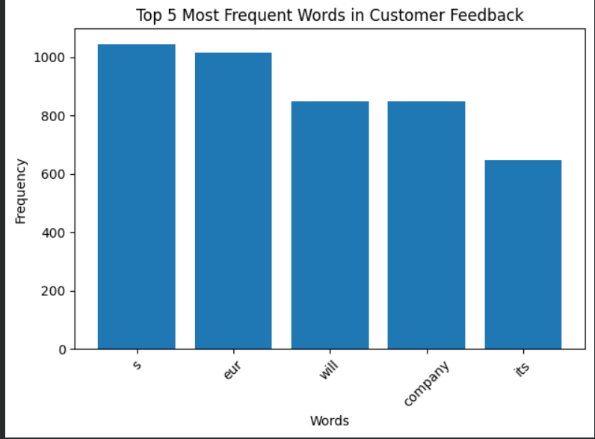

Experiment 18
Program:
import pandas as pd
import matplotlib.pyplot as plt
from scipy import stats
df = pd.read_excel("age_bodyfat.csv")
print("\nDescriptive Statistics:")
print(df.agg(["mean", "median", "std"]))

plt.figure()
df.boxplot()
plt.title("Boxplot of Age and Body Fat Percentage")
plt.ylabel("Values")
plt.show()

plt.figure()
plt.scatter(df["Age"], df["BodyFat"])
plt.xlabel("Age")
plt.ylabel("Body Fat Percentage")
plt.title("Scatter Plot of Age vs Body Fat Percentage")
plt.show()

plt.figure()
stats.probplot(df["Age"], plot=plt)
plt.title("Q-Q Plot for Age")
plt.show()

plt.figure()
stats.probplot(df["BodyFat"], plot=plt)
plt.title("Q-Q Plot for Body Fat Percentage")
plt.show()

Output:
Descriptive Statistics:
Age BodyFat
mean 46.444444 28.783333
median 51.000000 30.700000
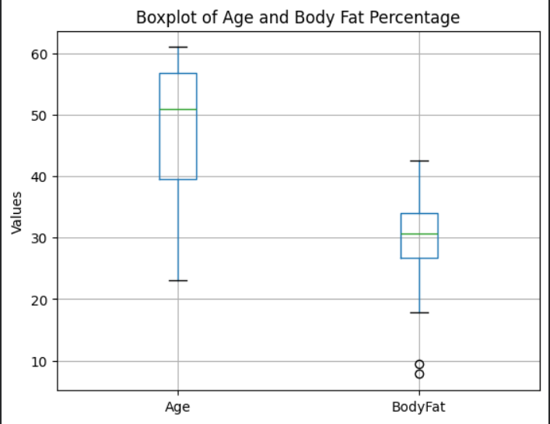
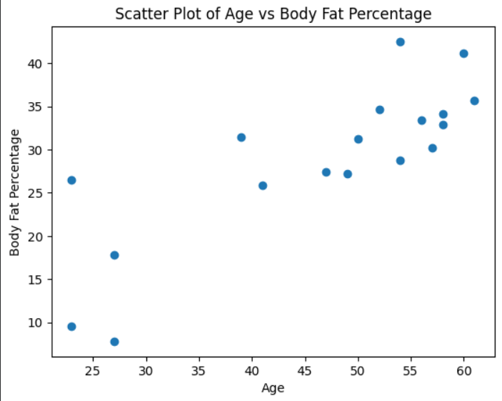
std 13.218624 9.254395

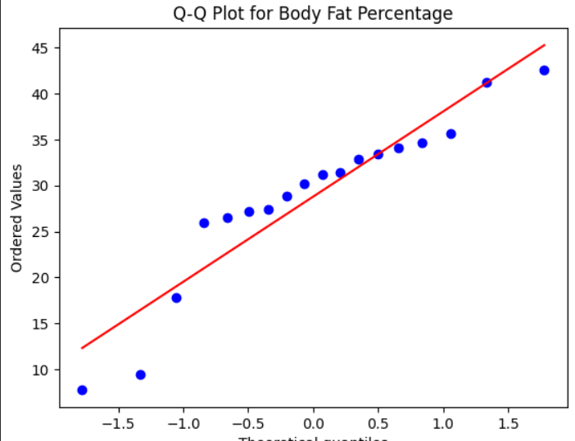
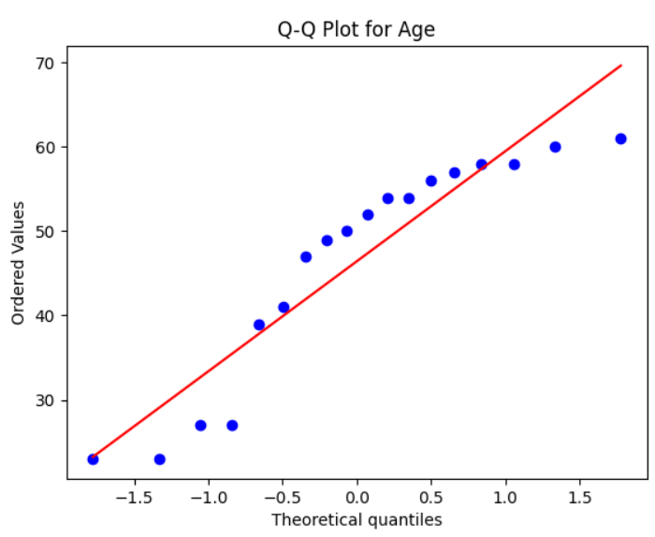

Experiment 19
Program:
import pandas as pd
import numpy as np
from scipy import stats

df = pd.read_excel("blood_pressure_reduction.csv")
print("Dataset Preview:")
print(df.head())
drug_group = df[df["Group"] == "Drug"]["Reduction_mmHg"]
placebo_group = df[df["Group"] == "Placebo"]["Reduction_mmHg"]
def confidence_interval(data, confidence=0.95):
mean = np.mean(data)
std = np.std(data, ddof=1)
n = len(data)
t_value = stats.t.ppf((1 + confidence) / 2, df=n - 1)
margin = t_value * (std / np.sqrt(n))
return mean - margin, mean + margin
drug_ci = confidence_interval(drug_group)
placebo_ci = confidence_interval(placebo_group)
print("\n95% Confidence Interval for Mean Reduction (Drug Group):")
print(drug_ci)
print("\n95% Confidence Interval for Mean Reduction (Placebo Group):")
print(placebo_ci)

Output:
95% Confidence Interval for Mean Reduction (Drug Group):
(np.float64(14.2246395926458), np.float64(16.175360407354198))

95% Confidence Interval for Mean Reduction (Placebo Group):
(np.float64(nan), np.float64(nan))

Experiment 20
Program:
import pandas as pd
from scipy import stats
df = pd.read_excel("ab_test_conversion.csv.xlsx")
design_A = df[df["Design"] == "A"]["Conversion_Rate"]
design_B = df[df["Design"] == "B"]["Conversion_Rate"]
t_stat, p_value = stats.ttest_ind(design_A, design_B)
print("\nT-statistic:", t_stat)
print("P-value:", p_value)
alpha = 0.05
if p_value < alpha:
print("Conclusion: There IS a statistically significant difference between Design A and Design B.")
else:
print("Conclusion: There is NO statistically significant difference between Design A and Design B.")

Output:
T-statistic: -8.28078671210825
P-value: 1.494274207413987e-07
Conclusion: There IS a statistically significant difference between Design A and Design B.

